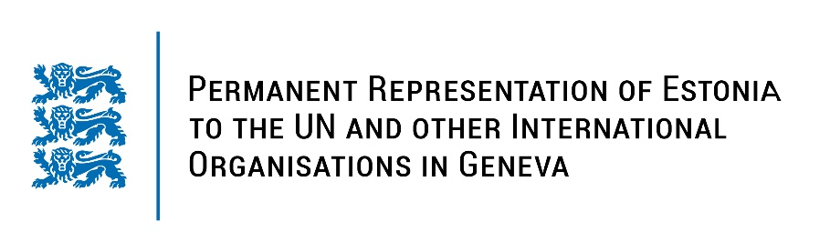
Universal Periodic Review of the Republic of Tunisia
8 November 2022
Intervention by the delegation of Estonia

Estonia welcomes the delegation of Tunisia to the 41st UPR session and thanks for the report and the information provided today.

Estonia commends Tunisia for the enactment of the Organic Law No. 22 of 2016 relating to the right of access to information, to help enrich public debate and promising to adhere to the principles of transparency and accountability. This could be developed further with the appointment of full-time agents tasked with accessing information in various public structures.

Estonia is concerned over Tunisia´s selective media freedom restrictions, especially the treatment befalling on journalists critical of power elites, including their prosecution before military tribunals and imposing severe penalties.

Estonia would therefore like to recommend Tunisia to:
- repeal Article 86 of the Communications Code;
- ensure media self-regulation by recognising the Press Council and support its work, including by providing a headquarters and stable public funding;
- refrain from prosecuting civilians, including journalists and media workers, before military tribunals;
- ratify the first and the Second Optional Protocol to the International Covenant on Civil and Political Rights (ICCPR).

Estonia wishes the delegation of Tunisia a successful review meeting.

I thank you!

