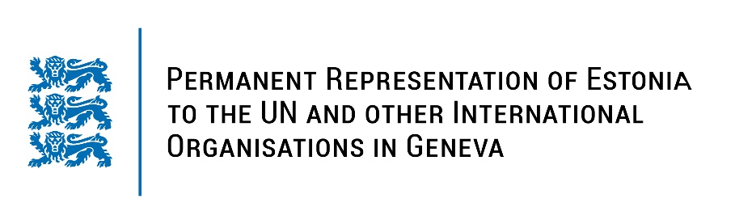
Universal Periodic Review of the Republic of Ecuador
7 November 2022
Intervention by the delegation of Estonia

Estonia welcomes the delegation of the Republic of Ecuador to the 41st UPR session and thanks for the report and the information provided today.

Estonia notes with appreciation that Ecuador has implemented several recommendations from the previous UPR cycles. We commend the positive developments that Ecuador has made in its international human rights commitments, including in the area of freedom of expression and protection of journalists. Estonia gladly notes the flourishing use of online educational programs to offer an alternative to Covid-19 pandemic´s hampering of traditional schooling. Estonia is sad to see, however, in parallel an increase in targeted bullying of girls and women online.
Following up on our previous recommendations, Estonia would like to recommend Ecuador to:
- strengthen the implementation of the existing legal framework regarding gender-based violence;
- intensify inclusive awareness-raising programmes to ensure that all women and girls have access to sexual and reproductive health care, including to modern forms of contraceptives;
- conduct awareness-raising campaigns for the mainstream “culture of equality”, to empower women’s access to political representation and decision making in the work field;
- establish effective consultation process with the indigenous peoples and communities concerned for any project that might affect their territory or livelihoods;
- take steps to ensure and protect the full independence and impartiality of the judiciary.

Estonia wishes the delegation of the Ecuador a successful review meeting.

I thank you!

