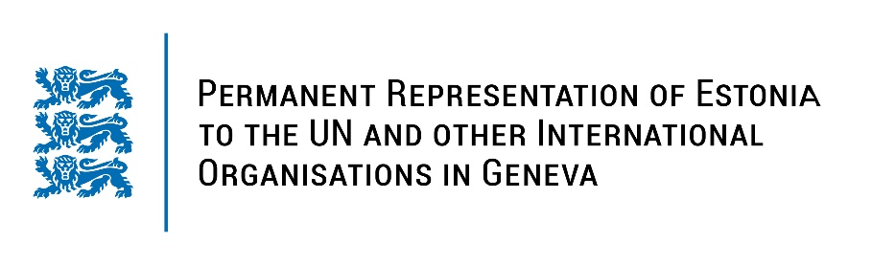
Universal Periodic Review of the Kingdom of Bahrain
7 November 2022
Intervention by the delegation of Estonia

Estonia welcomes the delegation of the Kingdom of Bahrain to the 41st UPR session and thanks for the report and the information provided today.

Estonia applauds Bahrain for adopting a National Human Rights Plan with specific goals and deliverables encompassing civil, economic and social rights, women empowerment and gender equality. Estonia also notes with appreciation the attempts to eradicate religious discrimination and highlights progress in the juvenile justice field, whereby minors are sent to juvenile detention instead of prison.

However, we note that not all of the recommendations made during previous review cycles have been implemented, thus we see the need to reiterate the recommendations. We recommend to Bahrain to:
- ratify the Rome Statute of the International Criminal Court;
- ratify the first and the Second Optional Protocol to the International Covenant on Civil and Political Rights (ICCPR);
- ratify the Optional Protocol to the Convention against Torture and Other Cruel, Inhuman or Degrading Treatment or Punishment;
- conduct impartial, thorough and effective investigations into all cases of attacks, harassment and intimidation against civil society activists, Human Rights Defenders, journalists and media workers.

Estonia wishes the delegation of the Kingdom of Bahrain a fruitful review meeting.

I thank you!

