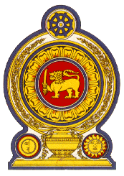

41st Session of the Universal Periodic Review

Review of Tunisia

08 November 2022

Statement by the Democratic Socialist Republic of Sri Lanka

Mr President,

Sri Lanka warmly welcomes the delegation of Tunisia and appreciates their presentation.

We appreciate Tunisia’s continued engagement in the UPR Cycle. Sri Lanka welcomes the constitutional, legislative and institutional measures taken by Tunisia for the protection and promotion of human rights. Sri Lanka welcomes the initiatives taken by Tunisia to strengthen the National Judicial system by restructuring the Supreme Council of the Judiciary in 2022.

Sri Lanka positively noted the process of engagement by The Supreme Independent Authority for Elections with the aim of initiating progressive constitutional reforms in consultation with national stakeholders and the public.

In a constructive spirit, Sri Lanka recommends that Tunisia

- Continues to improve the rights of the women in the social, cultural, economic and political spheres.

- Continues to ensure right to education to all by enhancing access to education.

We wish Tunisia every success in its UPR engagement.

