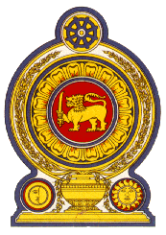

Statement by the Democratic Socialist Republic of Sri Lanka
41st Session of the Universal Periodic Review
Review of South Africa – 16 November 2022

Mr. President,

Sri Lanka warmly welcomes the delegation of South Africa and appreciates the presentation of a comprehensive national report.

We welcome the commitment of South Africa to prevent and combat trafficking of persons by the enactment of the TIP Act.

We also note the progress in establishing and upgrading post school education and training institutions in rural areas, including for students with disabilities, as well as the National Student Financial Aid Scheme to assist students from disadvantaged backgrounds.

We take this opportunity to recommend that South Africa

- Continue efforts to improve access to basic education as well as post school education and training for students in rural areas as well as from disadvantaged backgrounds.

- Further enhance efforts and strategies, including online training and capacity building to end violence against children and exploitation.

- Further enhance efforts to improve the health care system.

We wish South Africa every success in its UPR engagement.

Thank you.

(1 minute)

