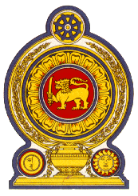

Statement by the Democratic Socialist Republic of Sri Lanka
41st Session of the Universal Periodic Review
Review of The Philippines – 14 November 2022

Mr. President,

Sri Lanka warmly welcomes the delegation of The Philippines and appreciates the presentation of a comprehensive national report.

Sri Lanka welcomes the commitment of the Philippines to comply with its international obligations and cooperate with human rights mechanisms, as evidenced by the ratification of eight core human rights treaties.

We acknowledge the progress achieved by the Philippines on its human rights commitments during the 3rd cycle and the full implementation of all 103 accepted recommendations.

We take this opportunity to recommend that The Philippines:

- Ensure universal access to health services and access to the Minimum Initial Service Package during emergencies and disasters.

- Continue the commitment towards the promotion and protection of the rights and welfare of migrant workers as enacted in the law of December 2021 creating the Department of Migrant Workers.

- Continue the priority afforded to maintaining access and delivery of public education and ensure access to education for groups in situations of disadvantage.

We wish The Philippines every success in its UPR engagement.

Thank you.

(1 minute and 05 seconds)

