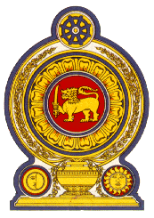

41st Session of the Universal Periodic Review

Review of Morocco

08 November 2022

Statement by the Democratic Socialist Republic of Sri Lanka

Mr President,

Sri Lanka extends a warm welcome to the delegation of Morocco and appreciates the presentation made.

We commend Morocco’s progress in protecting and promoting human rights since its last UPR. Sri Lanka noted with appreciation the National Action Plan for Democracy and Human Rights adopted by Morocco and its continued progress in line with Morocco’s government program 2021-2026.

In a constructive spirit, Sri Lanka recommends that Morocco:

-Continue to improve measures imposed by the National Commission aimed at combating and preventing human trafficking

-Further promotes the rights of the child by enhancing access to education and enrollment capacities.

-Continue to advance the rights of women and their public participation.

We wish Morocco success in its UPR engagement.

