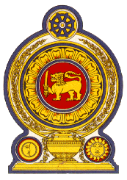

41st Session of the Universal Periodic Review

Review of Indonesia

09 November 2022

Statement by the Democratic Socialist Republic of Sri Lanka

Mr President,

Sri Lanka warmly welcomes the delegation of Indonesia and appreciates the presentation made.

We commend Indonesia’s constructive engagement with the UPR process and the progress made following the 3rd UPR cycle.

We further commend its ongoing progress in protecting and promoting of human rights including through launching of and the National Action Plan on Human Rights.

Sri Lanka welcomes the progressive, legislative and strategic measurers introduced by Indonesia to promote women’s and children’s rights, such as the enactment of the sexual violence crime law in April 2021. Further, we appreciate the implementation of additional measures to promote the employment and advancement of women in the economy and increased participation of women in public life including in legislative institutions.

In a constructive spirit, Sri Lanka recommends that Indonesia:

- Works towards the ratification of the Convention on the Rights of Persons with Disabilities (CRPD) in consultation with national stakeholders and in line with national priorities.

We wish Indonesia every success in its UPR engagement.

