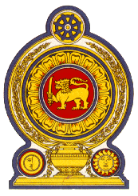

Statement by the Democratic Socialist Republic of Sri Lanka
41st Session of the Universal Periodic Review
Review of India – 10 November 2022

Mr. President,

Sri Lanka warmly welcomes the delegation of India and appreciates its comprehensive presentation.

We acknowledge India’s commitment to holistic, equitable and sustainable development goals and developmental initiatives undertaken with the objective of leaving no one behind.

We also note the importance afforded to education, ensuring safe drinking water and sanitation in rural areas, ensuring the safety and security of women and protection of persons with disabilities, including children.

We take this opportunity to recommend that India:

- Continues and strengthens efforts to ensure access to education for all children.

- Strengthens measures to combat violence against women and support victims and survivors of such violence.

- Develop polices in line with Sustainable Development Goals for the realization of the right to health.

Finally we wish India every success in its UPR engagement.

Thank you

(55 seconds).

