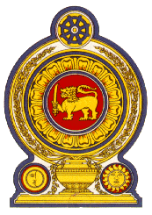

Statement by the Democratic Socialist Republic of Sri Lanka
41st Session of the Universal Periodic Review
Review of Brazil – 14 November 2022

Mr. President,

Sri Lanka warmly welcomes the delegation of Brazil and appreciates the presentation of a comprehensive national report.

We note the initiative of Brazil to reinforce its commitment to the UPR mechanism by presenting a mid-term report for the first time.

Sri Lanka also notes that Brazil has a strong record of cooperation with international and regional human rights mechanisms and that a standing invitation was extended for visits from all thematic Special Procedures.

It is commendable that Brazil currently hosts more than 345,000 migrants, refugees and asylum seekers and further, recognizes academic degrees of citizens from countries facing humanitarian crises.

We take this opportunity to recommend that Brazil:

- Considers ratifying the International Convention on the Protection of the Rights of Migrant Workers and Members of Their Families.

- Take further measures to promote participation of women in economic activities as well as to prioritize primary health care, particularly women’s health issues and maternal mortality.

We wish Brazil every success in its UPR engagement.

Thank you.

(1 minute)

