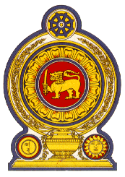

Statement by the Democratic Socialist Republic of Sri Lanka
41st Session of the Universal Periodic Review
Review of the People’s Democratic Republic of Algeria
11 November 2022

Mr. President,

Sri Lanka warmly welcomes the delegation of Algeria and appreciates its comprehensive presentation as well as the engagement with the HRC today.

We note the commitment of Algeria to the UPR process as illustrated by the acceptance of the majority of the recommendations made at the previous review.

The significant progress achieved in ensuring universal access to affordable healthcare for all, including migrants, is commendable.

We take this opportunity to recommend that Algeria:

- Promotes access to education for all including for those with disabilities.

- Further promote the participation of women in national economic development through processes and measures that provide financial and logistical support and assistance.

- Improves and broadens access to affordable health care for all, regardless of their status.

We wish Algeria every success in its UPR engagement and thank the delegation for its informative presentation.

Thank you.

(55 seconds)

