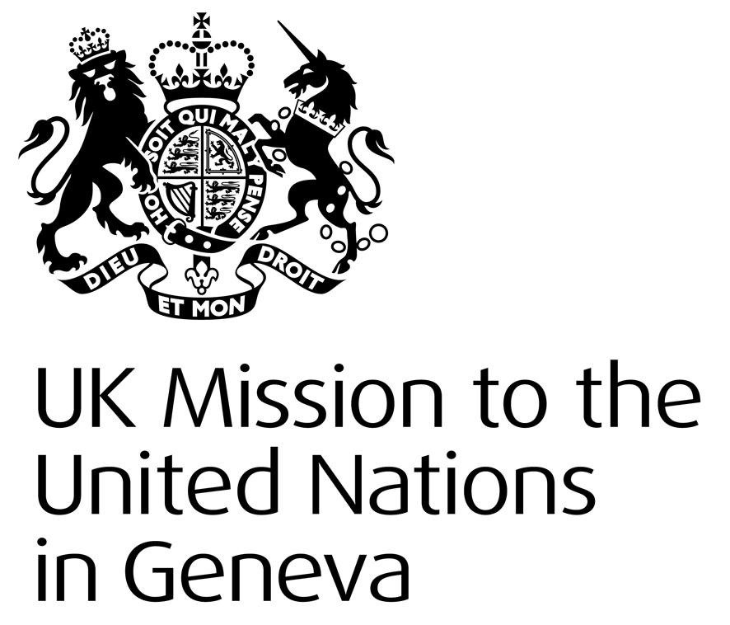
United Kingdom of Great Britain & Northern Ireland
Statement

41st Universal Periodic Review – Netherlands
Tuesday 14th November 2022

Thank you, Mr President.
The United Kingdom commends the Netherlands’ progress in furthering women’s rights and empowerment, including by narrowing the gender wage gap.
We recognise the Netherlands’ efforts to protect freedom of religion and expression and welcomes its decision to toughen the maximum penalties for crimes of incitement to hatred and violence
We also remain concerned by the murder of journalist Peter R. de Vries, and encourage the Government to strengthen mechanisms to protect journalists.
We recommend the Netherlands:
- Continue efforts to address threats to media freedom, especially in the form of intimidation and violence towards journalists.

- Take effective measures intended to mitigate the harmful effects of climate change on human rights, including empowering the vulnerable and least socio-economically resilient groups in the Dutch Caribbean.

- Increase availability of response centres in line with UNHCR recommendations and Dutch court rulings, and continue work to ensure that asylum seeker reception facilities meet international standards.

Thank you.

