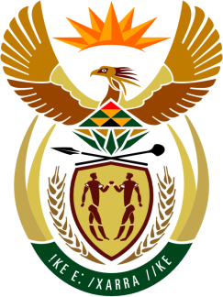

SOUTH AFRICAN PERMANENT MISSION
TO THE UNITED NATIONS
AND OTHER INTERNATIONAL ORGANISATIONS

41st SESSION OF THE WORKING GROUP ON THE
UNIVERSAL PERIODIC REVIEW

Review of Tunisia

8 november 2022

(60 Seconds)

speaker no: 119

Check against delivery

Mr. President,

South Africa welcomes the distinguished delegation of Tunisia to this UPR Session and wishes Tunisia a successful review.

South Africa commends Tunisia on the 2017 Law No. 58, on fighting violence against women, which includes key elements to prevent violence against women, protect domestic violence survivors, and prosecute abusers. In this regard the government is encouraged to ensure there is adequate funding and political will to put these programmes and policies fully into effect.

South Africa wishes to make the following recommendations:

- Take measures to provide free and compulsory primary education to all children paying particular attention to children living in poverty, rural areas, and children with disabilities.

- Refrain from prosecuting civilians in military courts.

- Restore Constitutional order and reinstate the Parliament and the constitutional institutions and bodies suspended or dissolved under the State of Emergency.

I thank you.

