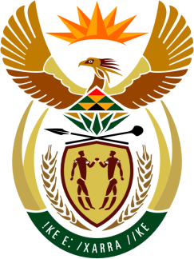

SOUTH AFRICAN PERMANENT MISSION
TO THE UNITED NATIONS
AND OTHER INTERNATIONAL ORGANISATIONS

41st SESSION OF THE WORKING GROUP ON THE
UNIVERSAL PERIODIC REVIEW

Review of UNITED KINGDOM (UK)

10 november 2022

(60 Seconds)

speaker no: 49

Check against delivery

Mr. President,

South Africa welcomes the distinguished delegation of UK to this UPR Session and wishes the country a successful review.

South Africa commends the UK on its Race Disparity Audit. We acknowledge the government’s action plan - building an Inclusive Britain.

South Africa would appreciate the UK’s comments on the findings of the Special Rapporteur on contemporary forms of racism, racial discrimination, xenophobia and related intolerance that the country still has much work to do in addressing structural forms of racial discrimination and equality, together with the response of the UN Working Group of Experts on People of African Descent to the report of the UK Commission to review Race and Ethnic Disparities on institutional racism in the country.

South Africa also wishes to make the following recommendations:

- Accelerate the implementation of the 20 actions contained in the agenda towards transformative change for racial justice and equality.
- Intensify the removal of structural barriers to racial and ethnic minority communities’ equal and non-discriminatory enjoyment of human rights.
- Make pay gap reporting on race and ethnicity mandatory.

I thank you

