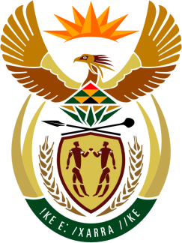

SOUTH AFRICAN PERMANENT MISSION

41st SESSION OF THE WORKING GROUP ON THE
UNIVERSAL PERIODIC REVIEW

Review of THE KINGDOM OF MOROCCO

8 NOVEMBER 2022
(14:30-18:00)

(55 seconds)

Check against delivery

Mister President,

South Africa welcomes the Honourable Minister of Justice, H.E. Abdellatif Ouahbi, and the distinguished delegation of Morocco to its 4th review under the UPR mechanism during this Session.

South Africa wishes to respectively recommend that Morocco:
- Enhance cooperation with the Office of the United Nations High Commissioner for Human Rights (OHCHR), including through urgently facilitating access by OHCHR to visit the Western Sahara region and allowing access to Sahrawi political prisoners.
- Respect all norms of International Humanitarian Law (IHL) in particular the provisions of the Fourth Geneva Convention (1949), and ensure that detainees in the Western Sahara are treated under human conditions;
- Accept the visit of the Working Group on Business and Human Rights and allow it to freely visit Western Sahara.
- Allow an independent assessment of the human rights situation in Western Sahara and Lift all measures limiting the freedom of movement of Saharawi human rights defenders and journalists;

My delegation welcomes the establishment of the National Preventive Mechanism on Torture and trust it will be adequately funded to execute its mandate.

South Africa wishes Morocco a successful review.

