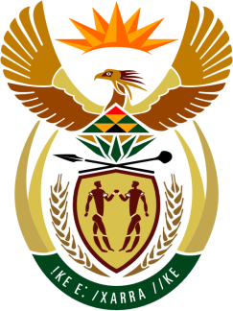

SOUTH AFRICAN PERMANENT MISSION
TO THE UNITED NATIONS
AND OTHER INTERNATIONAL ORGANISATIONS

41st SESSION OF THE WORKING GROUP ON THE
UNIVERSAL PERIODIC REVIEW

Review of BRAZIL

14 november 2022
14H30

(60 secONDS)

speaker no: 47

Check against delivery

Mr. President,

South Africa welcomes the distinguished delegation of Brazil to this UPR Session and wishes the country a successful review.

Our delegation commends Brazil on its enactment, in May 2022, of the Inter-American Convention against Racism, Racial Discrimination and Related Forms of Intolerance which has been incorporated in the country’s legal framework with Constitutional status. This is a fundamental step towards racial equality and justice.

In order to ensure progress in promoting and protecting human rights, South Africa recommends that Brazil:

- Strengthens the National Human Rights Council and aligns it with the Paris Principles;

- Enhance efforts, in cooperation with the international community, to stop deforestation, halt the extraction of national resources on lands of indigenous peoples without their consent, as well as the invasion of indigenous territories; and

- Strengthen measures, aimed at suppressing the use of child labour including through aligning the minimum age of employment with that of the end of compulsory education.

I thank you

