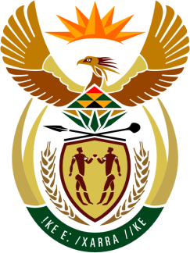

SOUTH AFRICAN PERMANENT MISSION
TO THE UNITED NATIONS
AND OTHER INTERNATIONAL ORGANISATIONS

41st SESSION OF THE WORKING GROUP ON THE
UNIVERSAL PERIODIC REVIEW

ALGERIA

11 november 2022

(55 Seconds)

speaker no: 113

Check against delivery

Mr. President,

South Africa welcomes the distinguished delegation of Algeria to this UPR Session and wishes the country a successful review.

South Africa commends Algeria for its new Constitution, including affording a prominent place to the country’s National Human Rights Council and the establishment of the National Civil Society Observatory, the Youth High Council and the Constitutional Court. We similarly acknowledge the reforms undertaken by Algeria in an endeavour to bring its human rights legislation in line with the Constitution and its international obligations. These efforts will certainly go some way in addressing the aspirations of the Hirak movement for political and social change.

South Africa wishes to make the following recommendations:
- Mainstream disability rights into the national implementation and monitoring of the 2030 Agenda for Sustainable Development and the Sustainable Development Goals.
- Continue to prevent and combat acts of violence against women, including by strengthening the institutions responsible for applying the existing legislative framework, providing them with the necessary resources, bolstering awareness-raising activities and training for State officials.
- Accelerate efforts to respect and protect the right to health of women and girls by removing barriers to their sexual and reproductive rights.
- Ensure that the National Human Rights Council complies with the Paris Principles relating to the status of national institutions for the promotion and protection of human rights.

I thank you

