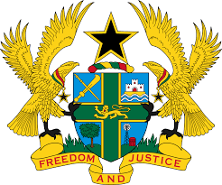

STATEMENT BY GHANA DELIVERED BY H.E EMMANUEL ANTWI, AMBASSADOR AND PERMANENT REPRESENTATIVE, DURING THE 41ST SESSION OF THE UPR WORKING GROUP ON MONDAY , 14TH NOVEMBER 2022

UNIVERSAL PERIODIC REVIEW OF THE PHILIPPINES

Thank you Mr President,

Ghana welcomes the delegation of the Philippines to the UPR Working Group. We commend the Government of Philippines for adopting the National Advocacy and Communication Strategic Plan (2017-20220) and the Philippine Development Plan (2017-2022), which intends to enhance the promotion and protection of human rights in the country. We further acknowledge the efforts made to improve access to justice for the vulnerable, including persons with disabilities.

To further consolidate democracy and respect for rule of law in the country, Ghana recommends that the Philippines should:
- Provide adequate protection to journalists and human rights defenders, to halt the spate of enforced disappearances and extrajudicial killings;
- Adopt strategies to address overcrowding in detention facilities;
- Hold perpetrators of alleged cases of torture and other cruel, inhuman, degrading treatment accountable and finally;
- Grant unrestricted access to the Special Rapporteur on extrajudicial summary or arbitrary executions.

We wish the Philippines a successful UPR outcome.

I thank you.

