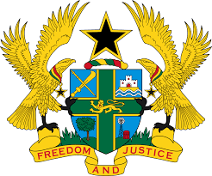
STATEMENT BY GHANA DELIVERED BY H.E EMMANUEL ANTWI, AMBASSADOR AND PERMANENT REPRESENTATIVE, DURING THE 41ST SESSION OF THE UPR WORKING GROUP ON THURSDAY, 10TH NOVEMBER 2022

UNIVERSAL PERIODIC REVIEW OF INDIA

Thank you Mr President,

Ghana welcomes the delegation of India and thank them for the presentation of their national report. The strategies adopted by the Government of India to combat corruption and alleviate poverty are highly commendable. We further applaud the establishment of the National Legal Services Authority to provide free legal aid to the underprivileged, marginalised and vulnerable in the country.
In the spirit of constructive dialogue, Ghana recommends that India:
- Establishes a national action plan for combating hate crimes, racism and negative stereotypes against people of African descent and ensure that perpetrators of such crimes are held accountable and also;
- India should intensify its efforts to ratify the United Nations Convention against Torture and Other Cruel, Inhuman or Degrading Treatment or Punishment (UNCAT) and its Optional Protocol.

We wish India success with the review process.

I thank you.

