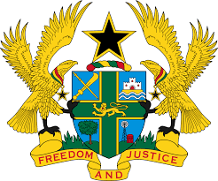
STATEMENT BY GHANA DELIVERED BY H.E EMMANUEL ANTWI, AMBASSADOR AND PERMANENT REPRESENTATIVE, DURING THE 41ST SESSION OF THE UPR WORKING GROUP ON
WEDNESDAY, 16TH NOVEMBER 2022

UNIVERSAL PERIODIC REVIEW OF SOUTH AFRICA

Thank you Mr President,

Ghana welcomes the delegation of South Africa and thank them for the presentation of their national report.
We welcome the ratification of the Optional Protocol to the Convention against Torture (OPCAT) and the designation of a multiple-body National Preventive Mechanism, under the coordination of the South African Human Rights Commission. The strategies adopted by the Government of South Africa to combat corruption in the country is also very commendable. We further acknowledge the adoption of the National Health Insurance (NHI) Bill and National Action Plan (NAP) to Combat Racism, Racial Discrimination, and Xenophobia and related Intolerance.
To further protect and promote human rights in the country, Ghana recommends that South Africa should:
- Increase efforts in guaranteeing women's access to justice and adopt strategies to protect women and girls against gender-based violence and finally;
- Continue to effectively combat xenophobia and hold perpetrators of such crimes accountable.
We wish South Africa every success with the review process.

I thank you.

