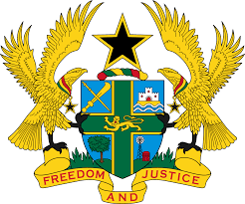
STATEMENT BY GHANA DELIVERED BY H.E EMMANUEL ANTWI, AMBASSADOR AND PERMANENT REPRESENTATIVE, DURING THE 41ST SESSION OF THE UPR WORKING GROUP ON TUESDAY , 15TH NOVEMBER 2022

UNIVERSAL PERIODIC REVIEW OF THE NETHERLANDS

Thank you Mr President,

Ghana welcomes the delegation of The Netherlands to the UPR Working Group.
We acknowledge the appointment of the National Coordinator against Discrimination and Racism (NCDR) and the adoption of Aruba’s first national gender policy to improve access to justice and providing gender-sensitive healthcare. We also commend the Government for the strategies adopted to combat domestic violence and child abuse in The Netherlands. The ‘Violence has no place in the home’ programme is therefore commendable.

To further enhance The Netherlands’s commitment to the protection of Human Rights, Ghana recommends that the Netherlands should:
- Consider ratifying the Convention on the Protection of the Rights of All Migrant Workers and Members of Their Families (ICRMW);
- Intensify efforts to ratify the Optional Protocol to the Convention on the Rights of Persons with Disabilities and finally;
- Continue to take measures to combat the persistence of violence against women, including domestic violence.
Ghana wishes The Netherlands success with the UPR outcome.

I thank you.

