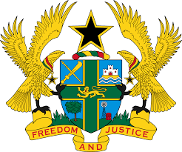

STATEMENT BY GHANA DELIVERED BY H.E. EMMANUEL ANTWI, AMBASSADOR AND PERMANENT REPRESENTATIVE, DURING THE 41ST SESSION OF THE UPR WORKING GROUP ON MONDAY, 14TH NOVEMBER 2022

UNIVERSAL PERIODIC REVIEW OF BRAZIL

Thank you Mr President,

Ghana welcomes the delegation of Brazil and thank them for the presentation of their national report. We commend Brazil for the establishment of the Emergency Aid Fund to reduce poverty and enhance social development. We further applaud Brazil for the adoption of the National Programmes to combat violence against children and adolescents and also commend the country for co-operating with human rights mechanisms.
Ghana would like to make the following recommendations to Brazil for its consideration:
- Reinforced comprehensive policies to confront racism and aggravated discrimination against people of African descent and indigenous peoples;
- Adopt strategies to promote freedom of expression and finally;
- Strengthen measures to prevent abuses by some law enforcement officials, including providing appropriate human rights training.

We wish Brazil every success in the implementation of the recommendations of this UPR process.

I thank you.

