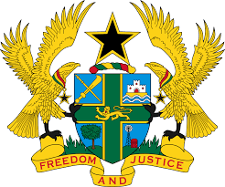
STATEMENT BY GHANA DELIVERED BY H.E EMMANUEL ANTWI, AMBASSADOR AND PERMANENT REPRESENTATIVE, DURING THE 41ST SESSION OF THE UPR WORKING GROUP ON THURSDAY , 10TH NOVEMBER 2022

UNIVERSAL PERIODIC REVIEW OF THE UNITED KINGDOM OF GREAT BRITAIN AND NORTHERN IRELAND

Thank you Mr President,

Ghana welcomes the delegation of the United Kingdom (UK) to the UPR Working Group.
We note the strong commitment by UK in promoting and protecting universal human rights in the country and therefore commend the Government for the strategies put in place in this regard. Of note is the establishment of the Hate Crime Action Plan to tackle hate crime and the Ending Destitution Together Strategy. We further acknowledge the efforts made to achieve a sustainable, long-term approach in tackling poverty, through a robust welfare system.

To further enhance the UK’s commitment to the protection of Human Rights, Ghana recommends that the UK:
- Considers ratifying outstanding Conventions such as the International Convention on the Protection of the Rights of All Migrant Workers and Members of Their Families (ICRMW) and secondly;
- Reinforce measures to combat all forms of discrimination and inequality.

We wish the UK a successful UPR outcome.

I thank you.

