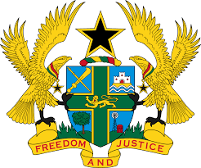
STATEMENT BY GHANA DELIVERED BY H.E EMMANUEL ANTWI, AMBASSADOR AND PERMANENT REPRESENTATIVE, DURING THE 41ST SESSION OF THE UPR WORKING GROUP ON FRIDAY, 11TH NOVEMBER 2022

UNIVERSAL PERIODIC REVIEW OF ALGERIA

Thank you Mr President,

Ghana welcomes the delegation of Algeria and thank them for the presentation of their national report. We commend Algeria for adopting a new constitution which will enhance the promotion and protection of human rights. We further applaud Algeria for cooperating with human rights mechanisms, especially the extension of invitations to six human rights mandate holders.
To further enhance Algeria’s commitment to the protection of Human Rights, Ghana recommends that Algeria should:
- Intensifies efforts to ratify the Optional Protocol to the Convention against Torture and Other Cruel, Inhuman or Degrading Treatment or Punishment (OP-CAT);
- Consolidate measures to ensure gender parity and combat violence against women and thirdly;
- Adopt measures to ensure that international norms on freedom of religion and belief are fully respected.
We wish Algeria success with the review process.

I thank you.

