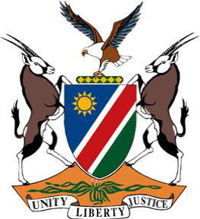
REPUBLIC OF NAMIBIA
Statement by Tangi Shikongo, 41st Working Group of the Universal Periodic Review, 4th Cycle UPR of the Kingdom of Bahrain, 07 November 2022

Thank you, Mr. President,

Namibia warmly welcomes the esteemed delegation of the Kingdom of Bahrain and thank them for submitting a comprehensive national report outlining the human rights impacting measures taken during the period under review.

Namibia is particularly pleased to note that, despite the challenges occasioned by the COVID-19 pandemic, Bahrain continues to take active measures to further advance and protect human rights of persons on its territory. Namibia also commends Bahrain for adopting legislation aimed at protecting children from ill-treatment.

While commending Bahrain for the positive human rights impacting measures, we note that there remains room for improvement, and in the spirit of constructive dialogue we make the following recommendations for consideration by Bahrain:

- Reinstate the de-facto moratorium on the death penalty and commute all death sentences;

- Withdraw all reservations to the Convention on the Elimination of All Forms of Discrimination against Women.

We wish the delegation of the Kingdom of Bahrain a successful review.

I thank you Mr. President.

