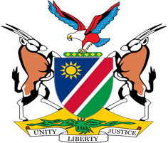

Statement by Jerry Mika, UPR of the Philippines, 11 November 2022
Speaking time: 1 min 05 seconds

- Thank You Mr. President,

- Namibia welcomes this opportunity to have a constructive dialogue with the esteemed delegation of the Philippines on the human rights impacting measures taken during the period under review.

- Namibia, amongst other things, applauds the Philippines for measures taken to advance protection for the rights of children and the premium it places on protecting the environment and addressing climate change.
- In the spirit of constructive dialogue with offer the following recommendations for consideration by the Philippines:

  - Ratify the Optional Protocol to the Convention on the Rights of Persons with Disabilities.
  - Ratify the International Labour Organisation’s Violence and Harassment Convention (No. 190) of 2019.

- We wish the delegation of the Philippines a successful review

6. I thank you Mr. President.

