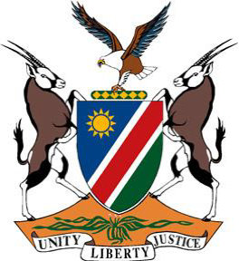
REPUBLIC OF NAMIBIA

Statement by Tangi Shikongo, 41st Session, UPR of Brazil, 14 November 2022

Thank you, Mr. President,

Namibia warmly welcomes the esteemed delegation of Brazil to the fourth cycle UPR and congratulates them for the comprehensive national report presented today.

Namibia has taken note with appreciation of the policy, legislative, judicial, administrative and financial measures taken by Brazil during the period under review to promote and protect the human rights of persons on its territory. We, among other things, applaud Brazil for its human rights education programme which has benefitted more than 600 000 people over a period of 12 years.

To further strengthen human rights in Brazil, we offer the following recommendations for consideration by Brazil:

1. Take effective measures to address structural racism, discrimination and violence against people of African descent;

2. Accede to the Treaty on the Prohibition of Nuclear Weapons.

We wish the delegation of Brazil a successful review.

I thank you, Mr. President.

