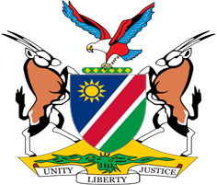

Statement by Jerry Mika, Deputy Permanent Representative, UPR of the Kingdom of the Netherlands, 15 November 2022

Speaking Time: 1-minute 10seconds

- Thank you, Mr. President,

- Namibia warmly welcomes the esteemed delegation of the Kingdom of the Netherlands and thank them for submitting a comprehensive national report as well as for the additional information provided today.

- Namibia has taken note of the improvements made by the Netherlands in the area of human rights promotion and protection, notwithstanding the challenges presented by the COVID-19 pandemic. The renewed approach to discrimination and racism of the Netherlands, including the appointment of a National Coordinator on this subject-matter, is commendable.

- There, however, remains room for further improvement and in the spirit of constructive dialogue we offer the following recommendations for consideration by the Netherlands:

  - Strengthen efforts to combat hate speech and incitement to discrimination or violence on racial, ethnic or religious grounds.

  - Withdraw all interpretative declarations to the Convention on the Rights of the Child.

- We wish the delegation of the Netherlands a successful review.

- I thank you Mr. President.

