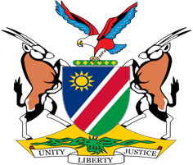

Statement by Jerry Mika, Deputy Permanent Representative, UPR of India, 10 November 2022

Speaking Time: 55 seconds

- Thank you, Mr. President,

- Namibia warmly welcomes the esteemed delegation of India and thank them for submitting a comprehensive national report outlining the progress made in promoting and protecting human rights in India since the last review in 2017. We commend India for the remarkable efforts, which amongst others, include the establishment of national institutions to address violence against women and girls.

- There, however, remains room for improvement and Namibia, therefore, offers the following recommendations for consideration by India:

  - Ratify the Optional Protocol to the Convention on the Elimination of All Forms of Discrimination against Women;

  - Ratify the UN Convention relating to the Status of the Refugees and its 1967 Protocol

- We wish the delegation of India a successful review.

- I thank you Mr. President.

