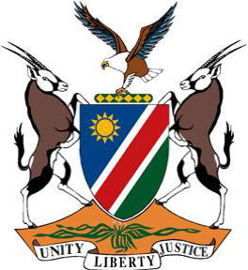
REPUBLIC OF NAMIBIA

Statement by Ms. Tangi Shikongo, 41st Session, UPR of the United Kingdom of Great Britain and Northern Ireland, 10 November 2022

Thank you, Mr. President,

Namibia welcomes this opportunity to have a constructive dialogue with the esteemed delegation of the United Kingdom.

Namibia commends the UK government’s approach towards addressing poverty, which has lifted more than a million people in the UK out of absolute poverty over a period of 10 years.

We note, however, that the UK needs to do more to tackle racism, and other related intolerances and, therefore, recommend that the UK:

1. Withdraw its interpretative declaration to Article 4 of the International Convention on the Elimination of All Forms of Racial Discrimination;

2. Take effective measures to address institutional racism, including by removing structural barriers that prevent racial and ethnic minority communities from enjoying human rights on an equal and non-discriminatory basis.

We wish the delegation of the United Kingdom a successful review.

I thank you, Mr. President.

