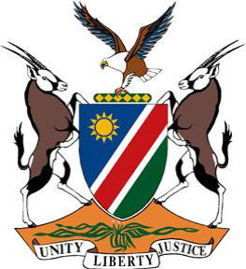
REPUBLIC OF NAMIBIA
Statement by Tangi Shikongo, 41st Working Group of the Universal Periodic Review, 4th Cycle UPR of the Indonesia, 09 November 2022

Speaking Time: 1 min 05 seconds

Thank you, Mr. President,

Namibia extends a cordial welcome to the esteemed delegation of Indonesia, and we take this opportunity to applaud Indonesia for her unwavering commitment to further promote and protect the human rights of all persons on its territory.

This is evidenced amongst others by Indonesia’s continued cooperation with UN Human Rights Mechanisms and its ratification of 8 out of the 9-core international human rights instruments.

In the spirit of constructive dialogue, Namibia makes the following recommendations for consideration by Indonesia:

1. Ratify the International Labour Organization’s Domestic Workers Convention (No. 189) of 2011;

2. Ratify the Optional Protocol to the Convention on the Elimination of All Forms of Discrimination against Women.

We wish the delegation of Indonesia a successful 4th Cycle Universal Periodic Review.

I thank you, Mr. President.

