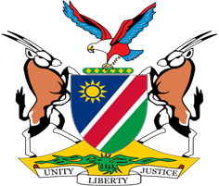

Statement by Mr. Jerry Mika, 41st session, UPR of Tunisia, 08 November 2022

Time: 1 minute

- Thank you, Mr. President,

- Namibia warmly welcomes the esteemed delegation of Tunisia to the UPR and thank them for their continued cooperation with mechanisms of the Human Rights Council, including the Universal Period Review.

- We commend Tunisia for ratifying the majority of international human rights instruments, along with regional instruments such as the Maputo Protocol on the rights of women in Africa and the Lanzarote Convention on the Protection of Children against Sexual Exploitation and Sexual Abuse. The implementation of these international and regional instruments will significantly promote and protect human rights in Tunisia.

- In the spirit of constructive dialogue, Namibia makes the following recommendations for consideration by Tunisia:

  - Ensure that sentences of persons who remain under sentence of death are commuted without delay;

  - Establish a National Human Rights Commission in accordance with the Paris Principles.

- We wish the delegation of Tunisia a successful review.

- I thank you, Mr. President.

