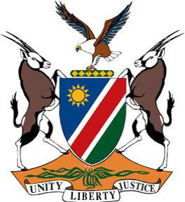
REPUBLIC OF NAMIBIA

Statement by H.E. Julia Imene-Chanduru, Ambassador/Permanent Representative, UPR of the Republic of South Africa, 16 November 2022

Thank you, Mr. President,

Namibia warmly welcomes the esteemed delegation from the sisterly Republic of South Africa, led by Honorable John Jeffrey, Deputy Minister of Justice, and Constitutional Development.

We take this opportunity to congratulate and commend South Africa for the positive human rights measures taken since its last review. The Governments efforts to reduce unemployment, including the Presidential Youth Employment Initiative, are among the measures that have found our admiration.

In the spirit of constructive dialogue, we offer the following two recommendations for consideration by South Africa:

1. Take effective measures to combat illicit financial flows and tax avoidance;

2. Strengthen the monitoring and implementation of the National Strategic Plan on Gender-Based Violence and Femicide.

We wish the delegation a successful review and congratulate South Africa for their election to the Human Rights Council.

I thank you, Mr. President.

