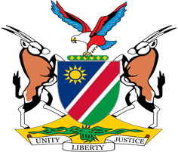

Statement by H.E. Julia Imene-Chanduru, Ambassador/Permanent Representative, UPR of Algeria , 11 November 2022

From: 09h00-12h30

Speaking Time: 55 seconds

- Thank you, Mr. President,

- Namibia warmly welcomes the esteemed delegation of Algeria to the 4th Cycle Universal Periodic Review. We praise Algeria for the progress made in the area of human rights promotion and protection since its last review. This includes amongst others the establishment of national institutions such as the Constitutional Court and the National Civil Society Observatory in 2021.

- In the spirit of constructive dialogue, we make the following recommendations for consideration by Algeria:

- Withdraw the reservations to the Convention on the Elimination of All Forms of Discrimination against Women;

- Ratify the International Labour Organisation’s Violence and Harassment Convention (No. 190) of 2019.

- We wish the delegation of Algeria a successful review.

- I thank you Mr. President.

