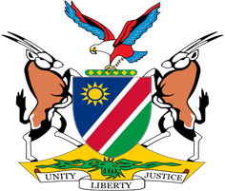

Statement by Mr. Jerry Mika, 41st session, UPR of Morocco, 08 November 2022

Time: 55 Seconds

- Mr. President,

- The right to self-determination is firmly established in international law. This right is not only enshrined in a number of international instruments, but it is also a peremptory norm from which no derogation is permitted. Notwithstanding this fact, the Kingdom of Morocco in total disregard of international law, continues to illegally occupy Western Sahara, whose people are yet to exercise their right to self-determination. To add insult to injury some States, in breach of their erga omnes obligations, continue to recognize the illegal occupation and actively collaborate with Morocco in violating the right to self-determination of the people of Western Sahara.

- Given this injustice, Namibia makes the following recommendations for implementation by Morocco:

  - Enable the people of Western Sahara to exercise their right to self-determination through a free, fair and transparent referendum administered by the United Nations;

  - Respect the Right of the People of Western Sahara to enjoy and utilize fully and freely their natural resources;

  - End restrictions on access to Western Sahara for UN Human Rights Mechanisms, journalists and human rights defenders.

In conclusion, we again call on all States to refrain from recognizing the illegal occupation of Morocco. It is a sad reality that some States have chosen economic expediency over well-established principles of international law.

- I thank you, Mr. President.

