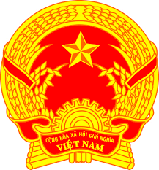
NATIONAL STATEMENT OF VIET NAM
41st Session of the UPR Working Group
Review of the Republic of South Africa
(16 November 2022, 09:00 – 12:30)
Delivered by Mr. LE Quang Binh, Permanent Mission of Viet Nam to the UNOG

Mister President,
Viet Nam thanks the delegation of South Africa for the comprehensive presentation of its national report.
We commend South Africa on its strong human rights framework and encourage South Africa to continue its efforts to fully implement its constitutional human rights protections.
In the spirit of amity and constructive dialogue, Viet Nam offers two recommendations:
- Develop a road map towards reducing unemployment, including through vocational training, programmes to meet labour market demands, and incentives for employers;
- Allocate adequate resources to narrow the large disparities in health care between the public and private systems, and between rural and urban areas;
Finally, we wish South Africa a successful UPR.
I thank you, Mister President.

