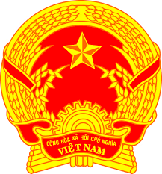
NATIONAL STATEMENT OF VIET NAM
41st Session of the UPR Working Group
Review of Brazil
(14 November 2022, 14:30 – 18:00)

Speaking Time: 60 seconds

Mister President,
Viet Nam warmly welcomes the delegation of Brazil and thanks it for the presentation today.
We appreciate Brazil's strong record of cooperation with international human rights mechanisms, particularly the standing invitation that Brazil extended to all thematic Special Procedures.
In a spirit of constructive dialogue and cooperation, Viet Nam recommends that Brazil:
1. Allocate adequate resources and funding to combat forced labour, child labour and the exploitation of women and uneducated individuals in rural areas for labour-intensive work;
2. Significantly invest in the education sector to reduce the marked disparity between urban and rural areas in educational opportunities at the high school and college levels.
3. Continue taking active measures aimed at improving gender equality in employment, participation in public affairs, and access to health care, particularly for women belonging to minority groups;
We wish Brazil every success with this UPR cycle.
Thank you, Mister President.

