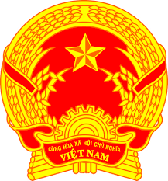
NATIONAL STATEMENT OF VIET NAM
41st Session of the UPR Working Group
Review of the Philippines
(14 November 2022, 09:00 – 12:30)

Speaking Time: 01 minute 05 seconds

Mister President,
Viet Nam commends the Philippines’ progress made since the last UPR and its constructive engagement with the UPR and mechanisms of the Human Rights Council.
Viet Nam recommends that the Philippines:
1. Better mitigate the social and economic difficulties caused by the COVID-19 pandemic on at-risk groups, such as women, children, and persons with disabilities;
2. Improve the preparedness and response of the Government in light of climate change-induced disasters and extreme weather events to minimize the loss of lives, livelihoods, and properties;
3. Enhance measures to address structural challenges relating to income inequality and poverty affecting the most vulnerable populations and communities in geographically isolated areas;
4. Continue to enhance laws and policies regarding access to education for the most disadvantaged learners.
Finally, we wish the Philippines every success with this UPR cycle.
Thank you, Mister President.

