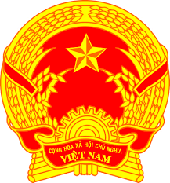
Statement of the Socialist Republic of Viet Nam
41st Session of the UPR Working Group
Review of Algeria
(Geneva, 11 November 2022)

Time: 55 seconds
Mister President,
Viet Nam thanks the delegation of Algeria for the comprehensive presentation of the national UPR report.
We commend Algeria for its legislative, institutional and policy initiatives to promote and protect human rights and achieve socio-economic development.
Viet Nam would like to make the following recommendations to Algeria:
First, continue promoting sustainable economic and social development and raising the living standard of its people so as to lay down a firm basis for the enjoyment of human rights by its people.
Second, continue efforts aimed at improving the access of persons with disabilities to education, vocational training and health care.
We wish Algeria every success with this UPR review.
Thank you, Mister President./.

