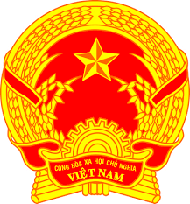
NATIONAL STATEMENT OF VIET NAM
41st Session of the UPR Working Group
Review of India
(10 November 2022, 14:30 – 18:00)

Speaking Time: 55 seconds

Mister President,
Viet Nam warmly welcomes the delegation of India and acknowledges its efforts to advance human rights.
Viet Nam makes the following recommendations:
- Continue to implement measures to increase livelihood opportunities and address rural poverty, especially for women empowerment;
- Strengthen the legislation on prohibition of child marriage to eradicate child and forced marriage;
- Develop relevant strategies to mitigate the impact of climate change on the effective enjoyment of human rights.
Finally, we wish India every success with this UPR cycle.
Thank you, Mister President./.

