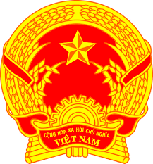
NATIONAL STATEMENT OF VIET NAM
41st Session of the UPR Working Group
Review of the United Kingdom of Great Britain and Northern Ireland
(10 November 2022, 09:00 – 12:30)

Speaking time: 60 seconds

Mister President,
Viet Nam welcomes the delegation of the United Kingdom of Great Britain and Northern Ireland.
Viet Nam appreciates the global leadership of the UK on gender and equalities. Since the last UPR review, the UK has continued to further incorporate major UN human rights treaties such as the CRC and CEDAW into domestic law and extend them to more British Overseas Territories.
We recommend the UK:
1. Increase opportunities for women to gain access to formal employment with equal pay for work of equal value;
2. Allocate more resources for poverty reduction and social welfare programs;
3. Strengthen investment and policy mix for job skills training aimed at reducing income inequality and leveling up opportunity for the working-age population.
I thank you, Mister President.

