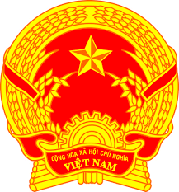
NATIONAL STATEMENT OF VIET NAM
41st Session of the UPR Working Group
Review of Indonesia
(09 November 2022, 09:00 – 12:30)

Speaking Time: 01 minute 05 seconds

Mister President,
Viet Nam warmly welcomes the delegation of Indonesia and thanks them for their national UPR report.
We appreciate the strong commitment of Indonesia to the promotion and protection of human rights and welcome the positive steps taken by Indonesia to ensure the safety and well-being of the people in response to the COVID-19 pandemic.
In the spirit of constructive engagement, my delegation recommends that Indonesia:
First, continue to advance the rights and well-being of women, with particular focus on enhancing their representation in decision-making, economic opportunities and combatting discrimination against women.
Second, improve the coverage and quality of essential health services, especially for groups in situations of poverty and persons living on small, remote islands and in the eastern provinces.
In conclusion, we congratulate Indonesia on assuming the Chairmanship of ASEAN for 2023 and wish Indonesia every success in fulfilling its human rights commitments.
I thank you, Mister President./.

