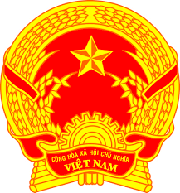
Statement of the Socialist Republic of Viet Nam
41st Session of the UPR Working Group
Review of Ecuador
(Geneva, 07 November 2022)

Time: 01 minute and 45 seconds
Mister President,
Viet Nam thanks the delegation of Ecuador for the comprehensive presentation of the national UPR report.
We appreciate the commitment to fulfilling its national and international human rights obligations and welcome the measures undertaken by Ecuador to implement recommendations since the adoption of its third UPR report. We commend the efforts of Ecuador to promote and protect the rights of persons with disabilities, including formulation of the national agenda for the period 2021–2025 to guide public and private efforts relating to disability.
In a spirit of constructive dialogue, Viet Nam would like to make the following recommendations to Ecuador:
First, continue its efforts to reduce violence based on gender.
Second, continue its efforts, including increasing social spending on education, to ensure universal and equal access to quality education.
Viet Nam wishes Ecuador a successful review.
Thank you, Mister President./.

