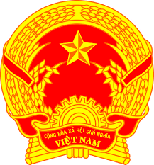
Statement of the Socialist Republic of Viet Nam
41st Session of the UPR Working Group
Review of Bahrain
(Geneva, 07 November 2022)

Time: 01 minute and 20 seconds
Mister President,
Viet Nam welcomes Bahrain’s national UPR report.
We appreciate the strong commitment to the promotion and protection of human rights and the measures taken by Bahrain to implement recommendations since the adoption of its third UPR report. We commend Bahrain’s steps to guarantee the application of principles of equality to protect all citizens during implementing of precautionary measures to address the COVID-19 pandemic.
In a spirit of constructive dialogue, Viet Nam would like to make the following recommendations to Bahrain:
First, implement more measures including allocation of more human, technical and financial resources to the health sector for further promotion of the right to health of the people.
Second, continue its efforts to promote and protect the rights of migrant workers, particularly women migrant workers with a view to protecting them from all forms of exploitation and ill-treatment.
We wish the delegation of Bahrain a very successful UPR process.
Thank you, Mister President./.

