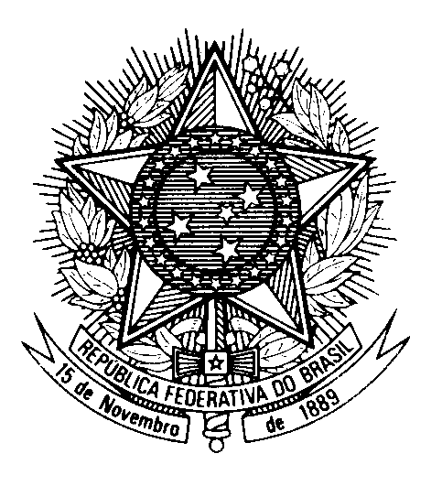
HRC UNIVERSAL PERIODIC REVIEW
REPUBLIC OF POLAND

(Geneva, November 15th 2022)

STATEMENT OF BRAZIL

Thank you.

Brazil welcomes the delegation of Poland to the forth cycle of the UPR.

We congratulate Poland on supporting cultural institutions and on preserving the memory and the legacy of the victims of World War II, in particular in the case of the Jewish people and the Holocaust.

Brazil also commends the Polish Government for the aid provided to families, especially for children and family members with disabilities. We note with appreciation the adoption of the National Action Plan for Equal Treatment 2022-2030.

Nonetheless, we express our concern over reports of discrimination against the LGBT community. We encourage Poland to take further measures to increase the participation of women in the labour force, particularly women with disabilities, Roma and older women.

In the spirit of cooperation and constructive dialogue, Brazil recommends that Poland:

1. Strengthen the legal framework pertaining to the independence of media regulation bodies;

2. Further policies to promote intercultural dialogue and mutual understanding with minority groups and religious communities.

Thank you.

