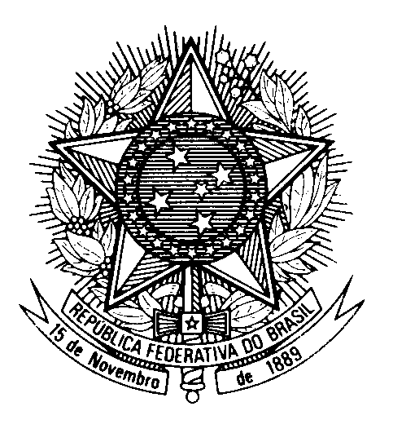
HRC UNIVERSAL PERIODIC REVIEW
REPUBLIC OF INDIA

(Geneva, November 11th 2022)

STATEMENT OF BRAZIL

Thank you.

Brazil welcomes the delegation of India to the fourth cycle of the UPR.

We appreciate India`s commitment to seeking universal access to affordable health care for all and in particular India’s sense of responsibility and solidarity by sharing COVID vaccines and response products to more than 150 countries.

We commend India for aligning the National Voluntary Guidelines on Social, Economic and Environmental Responsibilities of Business with the UN GOPs and the SDGs.

With a spirit of constructive dialogue, Brazil recommends India:

(i) to strengthen efforts to implement labour laws, especially concerning informal workers and women workers; and

(ii) to consider adopting regulations on the protection of personal data that ensure the rights of freedom of expression and privacy, in accordance with the existing international standards.

We wish India a successful review.

