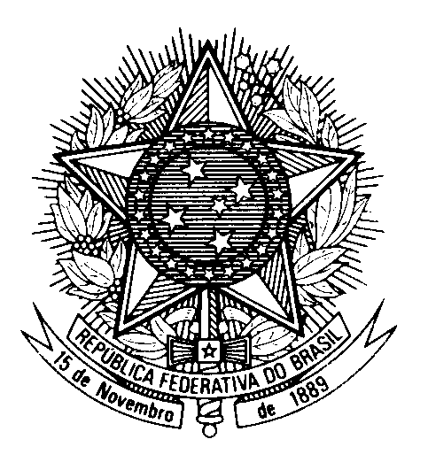
HRC UNIVERSAL PERIODIC REVIEW
UNITED KINGDOM OF GREAT BRITAIN AND NORTHERN IRELAND

(Geneva, November 10th 2022)

STATEMENT OF BRAZIL

Thank you.

Brazil welcomes the delegation of the United Kingdom to the fourth cycle of the UPR.

We congratulate the UK for the efforts to tackle violence against and exploitation, abuse and harassment of women and girls, as well as to counter the effects of the COVID-19 pandemic, including support for families, business, and the NHS.

Nevertheless, we remain concerned about the legislation applied to mass surveillance activities and to the protection of the right to privacy in the UK.

Brazil recommends to the UK:

1) The continued training of law enforcement officials for the proportionate use of force especially with regard to minority groups;

2) To advance measures to improve food security, in particular for young children, adolescents and persons with disabilities.

Thank you.

