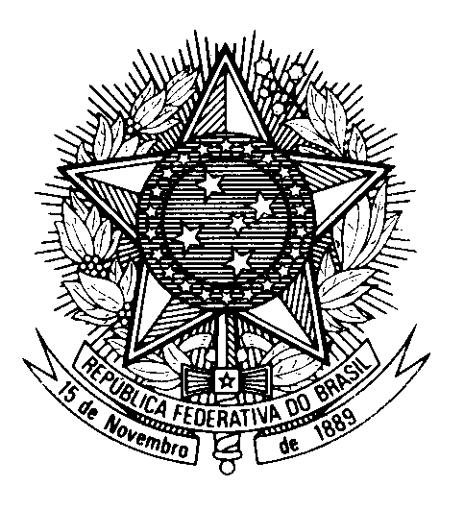

Statement by Ambassador Tovar da Silva Nunes,

Permanent Representative of Brazil to the United Nations Office,

in the review of Finland, during the 41th session of the Working Group

on the Universal Periodic Review

(Geneva, 9 Novewmber 2022)

Brazil welcomes Finland to the fourth cycle of the UPR.

We appreciate efforts to prevent discrimination, racism and xenophobia, as recommended by Brazil in the previous cycle. We remain concerned, however, about the high incidence of violence against women and discriminatory acts, particularly against the Sami population.

In this context, in a constructive spirit, we recommend Finland to:

1) Ratify the ILO Convention 169 on indigenous people`s rights and redouble efforts to ensure the realization of all the human rights of the indigenous Sámi people, particularly to a healthy environment and to receive education, social care and health services in their own language; and

2) Ensure the effective enforcement of the Istambul Convention and the implementation of the Action Plan for 2022-2025 to eradicate all types of violence against women and support victims of such crimes.

We wish Finland a successful review.

Thank you.

