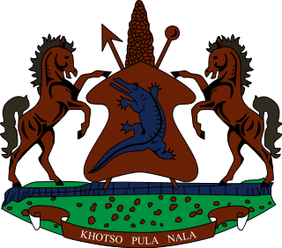

STATEMENT BY THE KINGDOM OF LESOTHO DURING THE 4TH UPR REVIEW OF TUNISIA

08 NOVEMBER, 2022

Thank you, Madam President,
Lesotho warmly welcomes the delegation of Tunisia to the Working Group. We take cognizance of the steps taken by Tunisia in various areas to promote and protect human rights of its people. We applaud Tunisia for developing the legal and policy framework to address overcrowding in detention centers. We further commend them for taking strides in addressing human trafficking.
At this point, we wish to make the following recommendations for consideration by Tunisia: 1. to redouble efforts to ensure a speedy establishment of the Constitutional Court and the appointment of its members. 2. To strengthen measures to combat domestic violence against women and children.
Finally, we wish Tunisia every success with this UPR cycle.
I thank you

