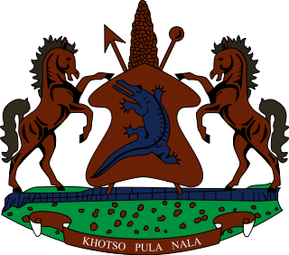

STATEMENT BY THE KINGDOM OF LESOTHO DURING THE 4TH UPR REVIEW OF UNITED KINGDOM

10 NOVEMBER, 2022

Thank you, Mr. President,
Lesotho welcomes to the delegation of the United Kingdom to the Working Group and thank them for the presentation of their National Report. We note steps taken by the UK in supporting people with disabilities in the employment sector. We further applaud UK for formulating the legal framework to ptotect women and girls from domestic violence.

Progress notwithstanding, Lesotho offers the following recommendations for consideration by the UK: 1. To ratify the Convention of the Rights of Migrant Worker. 2. To continue efforts to ensure that she submits her overdue State Party Reports to UN treaty bodies; and 3. To beef up measures to curb racially motivated hate crimes and discrimination against black and other ethnic minorities in schools.

We wish UK every success with this UPR cycle.

I thank you.

